Year 7 Science
Investigation - Growth of Beans

Name:

Aim: Write your aim similar to this: "To investigate the effect of coloured light on bean growth".

Hypothesis: Make a prediction about what you think will happen, similar to:
"Red light will make the plants grow the best".

Materials: List all of the materials you think you will need.

e.g. Petri dish, or plastic dish (for depth of planting).
Potting mix, or different soils if needed.
Etc.

Method: List your method as steps, using dot points.

e.g. • Take 5 petri dishes and fill them with potting mix.
• Plant 5 bean seeds into each.
• Etc.

Results: You need a table here. It is a bit tricky to do in Pages but try to set the table up as show in the photo below.

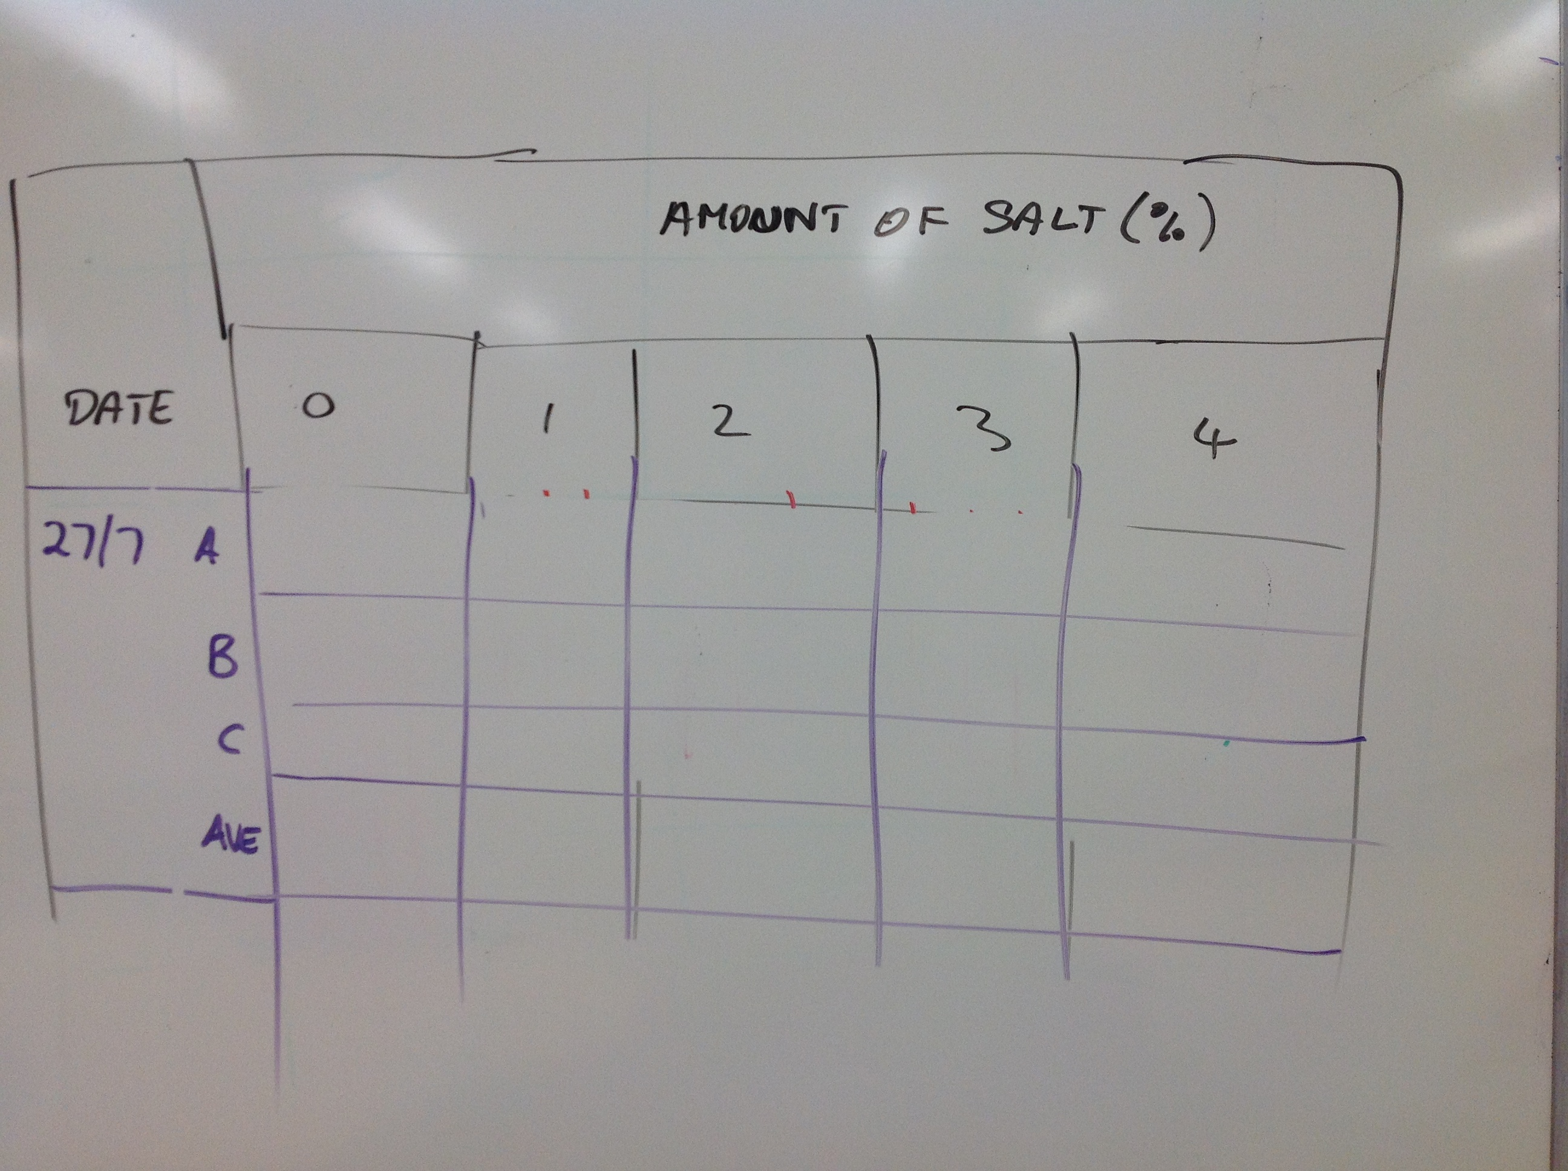

Discussion: An explanation of your results and a description of any difficulties you had with the experiment.

Conclusion: Answer the aim - what do your results tell you about the growth of the bean plants?

